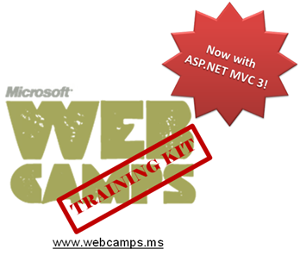

Hands-On Lab

ASP.NET MVC – Dependency Injection

Lab version: 1.1.0
Last updated: 5/27/2024

Contents
Overview 3
Exercise 1: Injecting a Controller 5
Task 1 – Running the Application 10
Task 2 – Including Unity into MvcMusicStore Solution 11
Task 3 – Adding a Unity Controller Factory 12
Task 4 – Registering Unity in Global.asax.[cs|vb] Application_Start 14
Task 5 – Running the Application 17
Exercise 2: Injecting a View 18
Task 1 – Creating a View that Consumes a Service 19
Task 2 – Including a Custom Dependency Resolver and a Custom View Page Activator 21
Task 3 – Registering for Dependency Injection in Global.asax.[cs|vb] Application_Start 25
Task 4 – Running the Application 29
Exercise 3: Injecting Action Filters 30
Task 1 – Including the Tracking Filter in the Solution 30
Task 2 – Registering and Enabling the Filter 35
Task 3 – Running the Application 38
Summary 41

Overview
Note: This Hands-on Lab assumes you have basic knowledge of ASP.NET MVC and ASP.NET MVC 3 filters. If you have not used ASP.NET MVC 3 filters before, we recommend you to go over ASP.NET MVC Custom Action Filters and MVC Global and Dynamic Action filters Hand-on Lab.

In Object Oriented Programming paradigm, objects work together in a collaboration model where there are contributors and consumers. Naturally, this communication model generates dependencies between objects and components that could became difficult to manage when complexity increases .
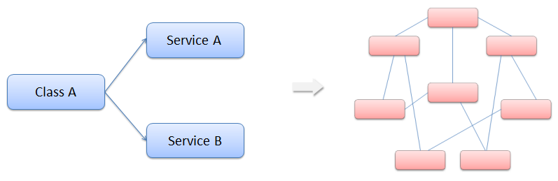
Figure 1
Class dependencies and model complexity

You have probably heard about the Factory Pattern and the separation between the interface and the implementation using services. However, the client objects are often responsible for service location.
Before introducing the Dependency Injection Pattern, we will explain what Inversion of Control (IoC) principle is.
With Inversion of Control (Ioc), consumer objects do not create the other objects on which they rely. Those objects come from an external source.

The Dependency Injection (DI) Design Pattern
Dependency injection (DI) design pattern is based on separating component behavior from dependency resolution without object intervention.
This pattern is a particular implementation of Inversion of Control, where the consumer object receives his dependencies inside constructor properties or arguments.
DI requires a framework component behind to deal with class constructor.
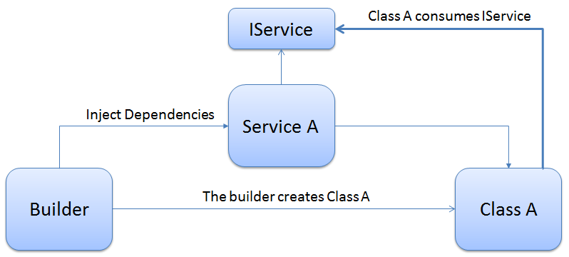
Figure 2
Overview – Dependency Injection diagram

The advantages of using Dependency Injection pattern and Inversion of Control are the following:
Reduces class coupling
Increases code reusing
Improves code maintainability
Improves application testing

Note: Depencency Injection is sometimes compared with Abstract Factory Design Pattern, but there is a slight difference between both approaches. DI has a Framework working behind to solve dependencies by calling the factories and the registered services.

Now that you understand the Dependency Injection Pattern, you will learn through this lab how to apply it on ASP.NET MVC 3. You will start using Dependency Injection on Controllers to include a service for database access. Next you will use Dependency Injection on Views to use a service inside a view and display information. Then, you will extend DI to MVC 3 Filters concept and inject a Custom Action Filter in the solution.
In this Hands-on Lab, you will learn how to:
Integrate MVC 3 with Unity Application Block for Dependency Injection
Use dependency injection inside an MVC Controller
Use dependency injection inside an MVC View
Use dependency injection inside an MVC Action Filter

Note: This Lab proposes Unity Application Block as the dependency resolver framework, but it is posible to adapt any Dependency Injection Framework to work with MVC 3.

System Requirements
You must have the following items to complete this lab:
ASP.NET and ASP.NET MVC 3
Visual Studio 2010
SQL Server Database (Express edition or above)
    - Note: You can install the previous system requirements by using the Web Platform Installer 3.0: http://go.microsoft.com/fwlink/?LinkID=194638.

Exercises
This Hands-On Lab is comprised by the following exercises:
  - Exercise 1: Injecting a Controller
  - Exercise 2: Injecting a View
  - Exercise 3: Injecting Filters

Estimated time to complete this lab: 30 minutes.
Note: Each exercise is accompanied by an End folder containing the resulting solution you should obtain after completing the exercises. You can use this solution as a guide if you need additional help working through the exercises.

Next Step
Exercise 1: Injecting a Controller

Exercise 1: Injecting a Controller
In this exercise, you will learn how to use Dependency Injection in MVC Controllers, by integrating Unity Application Block. For that reason you will include services into your MVC Music Store controllers to separate the logic from the data access. The service will create a new dependence into the controller constructor that will be resolved using Dependency Injection with the help of Unity application block.
With this approach you will learn how to generate less coupled applications, which are more flexible and easier to maintain and test. Additionally, you will also learn how to integrate MVC with Unity.

About StoreManager Service
The MVC Music Store provided in the begin solution now includes a service that manages the Store Controller data, StoreService. Below you will find the Store Service implementation. Note that all the methods return Model entities.
C# - StoreService.cs
using System;
using System.Collections.Generic;
using System.Linq;
using System.Web;
using MvcMusicStore.Models;

namespace MvcMusicStore.Services
{
public class StoreService : MvcMusicStore.Services.IStoreService
{
MusicStoreEntities storeDB = new MusicStoreEntities();

public IList<string> GetGenreNames()
{
var genres = from genre in storeDB.Genres
select genre.Name;

return genres.ToList();
}

public Genre GetGenreByName(string name)
{
var genre = storeDB.Genres.Include("Albums")
.Single(g => g.Name == name);
return genre;
}

public Album GetAlbum(int id)
{
var album = storeDB.Albums.Single(a => a.AlbumId == id);

return album;
}
}
}

Visual Basic - StoreService.vb
Public Class StoreService
Implements IStoreService
Private storeDB As New MusicStoreEntities

Public Function GetGenreNames() As IList(Of String) Implements IStoreService.GetGenreNames
Dim genres = From genre In storeDB.Genres
Select genre.Name

Return genres.ToList()
End Function

Public Function GetGenreByName(ByVal name As String) As Genre Implements IStoreService.GetGenreByName
Dim genre = storeDB.Genres.Include("Albums").Single(Function(g) g.Name = name)
Return genre
End Function

Public Function GetAlbum(ByVal id As Integer) As Album Implements IStoreService.GetAlbum
Dim album = storeDB.Albums.Single(Function(a) a.AlbumId = id)

Return album
End Function
End Class

Additionally, in the StoreController you will find in the begin solution now uses StoreService. All data references were removed from Store Controller, and therefore it is possible to modify the current data access provider without making changes at any method that consumes the Store Service.
You will find below that the Store Controller implementation has a dependency with the Store Service inside the class constructor.
Note: The dependency introduced in this exercise is related to MVC Inversion of Control (IoC).
The StoreController class constructor receives an IStoreService parameter, which is essential to perform service calls inside the class. However, StoreController does not implement the default constructor (with no parameters) that any controller must have to work with IoC.
To resolve the dependency, the controller should be created by an abstract factory (a class that returns any object of the specified type).

C# - StoreController.cs
using System;
using System.Collections.Generic;
using System.Linq;
using System.Web;
using System.Web.Mvc;
using MvcMusicStore.ViewModels;
using MvcMusicStore.Models;
using MvcMusicStore.Services;

namespace MvcMusicStore.Controllers
{
public class StoreController : Controller
{
private IStoreService service;

public StoreController(IStoreService service)
{
this.service = service;
}

//
// GET: /Store/
public ActionResult Index()
{
// Create list of genres
var genres = this.service.GetGenreNames();

// Create your view model
var viewModel = new StoreIndexViewModel
{
Genres = genres.ToList(),
NumberOfGenres = genres.Count()
};

return View(viewModel);
}

//
// GET: /Store/Browse?genre=Disco
public ActionResult Browse(string genre)
{
var genreModel = this.service.GetGenreByName(genre);

var viewModel = new StoreBrowseViewModel()
{
Genre = genreModel,
Albums = genreModel.Albums.ToList()
};

return View(viewModel);
}

//
// GET: /Store/Details/5
public ActionResult Details(int id)
{
var album = this.service.GetAlbum(id);

return View(album);
}
}
}

Visual Basic - StoreController.vb
Public Class StoreController
Inherits Controller
Private service As IStoreService

Public Sub New(ByVal service As IStoreService)
Me.service = service
End Sub

'
'GET: /Store/

Public Function Index() As ActionResult
'Create list of genres
Dim genres = Me.service.GetGenreNames()

'Create your view model
Dim viewModel = New StoreIndexViewModel With
{.Genres = genres.ToList(),
.NumberOfGenres = genres.Count()}

Return View(viewModel)
End Function

'
'GET: /Store/Browse?genre=Disco

Public Function Browse(ByVal genre As String) As ActionResult
Dim genreModel = Me.service.GetGenreByName(genre)

Dim viewModel = New StoreBrowseViewModel With
{.Genre = genreModel,
.Albums = genreModel.Albums.ToList()}

Return View(viewModel)
End Function

'
'GET: /Store/Details/5

Public Function Details(ByVal id As Integer) As ActionResult
Dim album = Me.service.GetAlbum(id)

Return View(album)
End Function
End Class

Note: You will get an error when a class tries to create this Store Controller without sending the service interface, because there is not a parameterless constructor declared.
Through this lab you will learn how to deal with this problem using Dependency Injection with Unity.

Task 1 – Running the Application
In this task, you will run the Begin application, which is now including the service into the Store Controller that separates the data access from the application logic.
After browsing to the store you will receive an exception since the controller service is not passed as a parameter by default:
  - Open the begin solution MvcMusicStore.sln at Source\Ex01-Injecting Controller\Begin.
  - Press F5 to run the application.
  - Browse to /Store to load Store Controller. You will get the error message “No parameterless constructor defined for this object”:
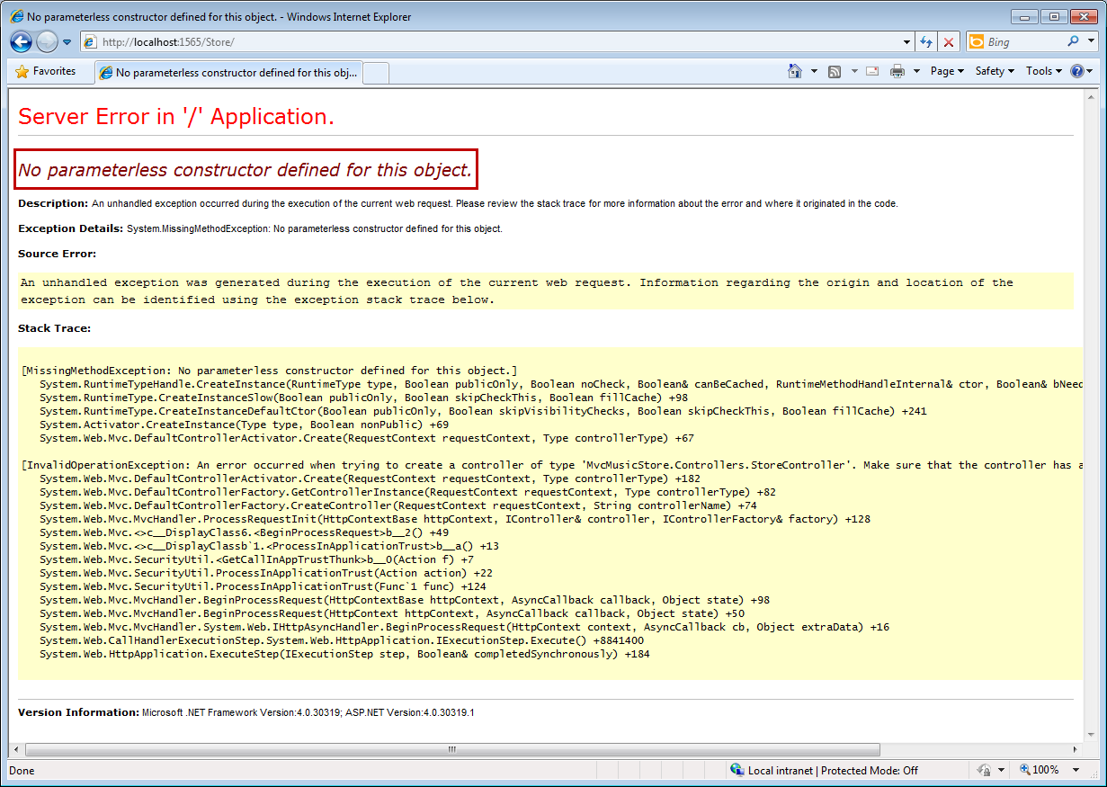
Figure 3
Error while running MVC Begin Application

  - Close the browser.

In the following steps you will work on the Music Store Solution to inject the dependency this controller needs.

Task 2 – Including Unity into MvcMusicStore Solution
In this task, you will include Unity Application Block 2.0 into your solution.
Note: The Unity Application Block (Unity) is a lightweight, extensible dependency injection container with optional support for instance and type interception. It’s a general-purpose container for use in any type of .NET application. It provides all the common features found in dependency injection mechanisms including: object creation, abstraction of requirements by specifying dependencies at runtime and flexibility, be deferring the component configuration to the container.
You could read more about Unity 2.0 at msdn.

  - Open the begin solution MvcMusicStore.sln at Source\Ex01-Injecting Controller\Begin.
  - In the MvcMusicStore project, add a reference to Microsoft.Practices.Unity.dll, which is included in Source\Assets\Unity 2.0\ folder of this lab.

Task 3 – Adding a Unity Controller Factory
In this task, you will add to the solution a custom controller factory for Unity. This class implements IControllerFactory interface, extending CreateController and ReleaseController methods to work with Unity. This factory will create the instances of the controllers that work with Dependency Injection.
Note: A controller factory is an implementation of the IControllerFactory interface, which is responsible both for locating a controller type and for instantiating an instance of that controller type.
The following implementation of CreateController finds the controller by name inside the Unity container and returns an instance if it was found. Otherwise, it delegates the creation of the controller to an inner factory. One of the advantages of this logic is that controllers can be registered by name.
You can find IControllerFactory interface reference at msdn.

  - In the MvcMusicStore project, create a new folder named Factories, and add the UnityControllerFactory class, which is included in the Source\Assets[C#|VB] folder of this lab.
C# - UnityControllerFactory.cs
using System;
using System.Collections.Generic;
using System.Linq;
using System.Web;
using System.Web.Mvc;
using Microsoft.Practices.Unity;
using System.Web.Routing;

namespace MvcMusicStore.Factories
{
public class UnityControllerFactory : IControllerFactory
{
private IUnityContainer _container;
private IControllerFactory _innerFactory;

public UnityControllerFactory(IUnityContainer container)
: this(container, new DefaultControllerFactory())
{
}

protected UnityControllerFactory(IUnityContainer container, IControllerFactory innerFactory)
{
_container = container;
_innerFactory = innerFactory;
}

public IController CreateController(RequestContext requestContext, string controllerName)
{
try
{
return _container.Resolve<IController>(controllerName);
}
catch (Exception)
{
return _innerFactory.CreateController(requestContext, controllerName);
}
}

public void ReleaseController(IController controller)
{
_container.Teardown(controller);
    - }

    - public System.Web.SessionState.SessionStateBehavior GetControllerSessionBehavior(RequestContext requestContext, string controllerName)
    - {
    - return System.Web.SessionState.SessionStateBehavior.Default;
    - }
}
}

    - Visual Basic - UnityControllerFactory.vb
    - Imports Microsoft.Practices.Unity

    - Public Class UnityControllerFactory
    - Implements IControllerFactory

    - Private _container As IUnityContainer
    - Private _innerFactory As IControllerFactory

    - Public Sub New(ByVal container As IUnityContainer)
    - Me.New(container, New DefaultControllerFactory)
    - End Sub

    - Protected Sub New(ByVal container As IUnityContainer,
    - ByVal innerFactory As IControllerFactory)

    - _container = container
    - _innerFactory = innerFactory
    - End Sub

    - Public Function CreateController(ByVal requestContext As RequestContext,
    - ByVal controllerName As String
    - ) As IController Implements IControllerFactory.CreateController

    - Try
    - Return _container.Resolve(Of IController)(controllerName)
    - Catch e1 As Exception
    - Return _innerFactory.CreateController(requestContext, controllerName)
    - End Try
    - End Function

    - Public Sub ReleaseController(ByVal controller As IController) Implements IControllerFactory.ReleaseController
    - _container.Teardown(controller)
    - End Sub

    - Public Function GetControllerSessionBehavior(ByVal requestContext As RequestContext, ByVal controllerName As String) As System.Web.SessionState.SessionStateBehavior Implements IControllerFactory.GetControllerSessionBehavior

    - Return System.Web.SessionState.SessionStateBehavior.Default
    - End Function

    - End Class

Note: This factory class can be reused in any project that uses Dependency Injection for Controllers.

Task 4 – Registering Unity in Global.asax.[cs|vb] Application_Start
In this task, you will register Unity library into Global.asax.[cs|vb] Application Start.
  - Open Global.asax.[cs|vb] file.
  - Include Microsoft.Practices.Unity Application Block, and references to the namespaces Services, Factories and Controllers:
(Code Snippet – ASP.NET MVC Dependency Injection – Ex1 Injecting Controllers Global using– Csharp)
C#
using System;
using System.Collections.Generic;
using System.Linq;
using System.Web;
using System.Web.Mvc;
using System.Web.Routing;
using Microsoft.Practices.Unity;
using MvcMusicStore.Services;
using MvcMusicStore.Factories;
using MvcMusicStore.Controllers;

    - (Code Snippet – ASP.NET MVC Dependency Injection – Ex1 Injecting Controllers Global using– VB)
    - Visual Basic
    - Imports System
    - Imports System.Collections.Generic
    - Imports System.Linq
    - Imports System.Web
    - Imports System.Web.Mvc
    - Imports System.Web.Routing
    - Imports Microsoft.Practices.Unity

  - Create a new Unity Container in Global.asax.[cs|vb] Application_Start and register the Store Service and the Store Controller.
    - (Code Snippet – ASP.NET MVC Dependency Injection –Ex1 Injecting Controllers Unity Container – Csharp)
C#
…
protected void Application_Start()
{
AreaRegistration.RegisterAllAreas();

RegisterGlobalFilters(GlobalFilters.Filters);
RegisterRoutes(RouteTable.Routes);

var container = new UnityContainer();
container.RegisterType<IStoreService, StoreService>();
container.RegisterType<IController, StoreController>("Store");

}
…

    - (Code Snippet – ASP.NET MVC Dependency Injection –Ex1 Injecting Controllers Unity Container – VB)
    - Visual Basic
    - …
    - Protected Sub Application_Start()
    - AreaRegistration.RegisterAllAreas()

    - RegisterGlobalFilters(GlobalFilters.Filters)
    - RegisterRoutes(RouteTable.Routes)

    - Dim container = New UnityContainer
    - container.RegisterType(Of IStoreService, StoreService)()
    - container.RegisterType(Of IController, StoreController)("Store")

    - End Sub
    - …

  - Register a UnityControllerFactory of the previous container inside MVC ControllerBuilder as the current factory for the controllers:
    - (Code Snippet – ASP.NET MVC Dependency Injection – Ex1 Injecting Controllers Global application start – Csharp)
C#
…
protected void Application_Start()
{
AreaRegistration.RegisterAllAreas();

RegisterGlobalFilters(GlobalFilters.Filters);
RegisterRoutes(RouteTable.Routes);

var container = new UnityContainer();
container.RegisterType<IStoreService, StoreService>();
container.RegisterType<IController, StoreController>("Store");

var factory = new UnityControllerFactory(container);
ControllerBuilder.Current.SetControllerFactory(factory);
}
…

    - (Code Snippet – ASP.NET MVC Dependency Injection – Ex1 Injecting Controllers Global application start – VB)
    - Visual Basic
    - …
    - Protected Sub Application_Start()
    - AreaRegistration.RegisterAllAreas()

    - RegisterGlobalFilters(GlobalFilters.Filters)
    - RegisterRoutes(RouteTable.Routes)

    - Dim container = New UnityContainer
    - container.RegisterType(Of IStoreService, StoreService)()
    - container.RegisterType(Of IController, StoreController)("Store")

    - Dim factory = New UnityControllerFactory(container)
    - ControllerBuilder.Current.SetControllerFactory(factory)

    - End Sub
    - …

Note: ControllerBuilder is an MVC class responsible for dynamically building a controller.
You can read more about ControllerBuilder at msdn.

Task 5 – Running the Application
In this task, you will run the application to verify that the Store can now be loaded after including Unity.
  - Press F5 to run the application.
  - Browse to /Store. This will invoke StoreController, which is now created by using UnityControllerFactory.
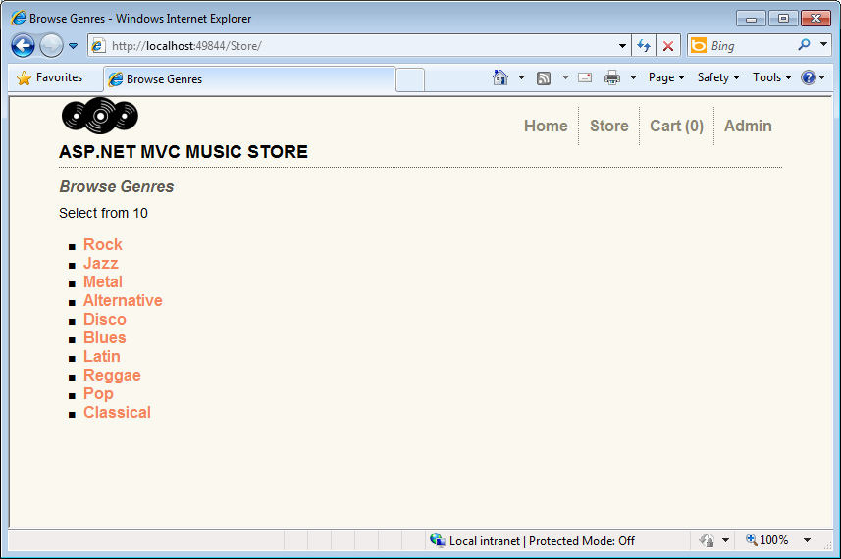
Figure 4
MVC Music Store

  - Close the browser.

In the following exercises you will learn how to extend the Dependency Injection scope, and use it inside MVC Views and Action Filters.

Next Step
Exercise 2: Injecting a View

Exercise 2: Injecting a View
In this exercise, you will learn how to apply Dependency Injection into a View by using new MVC 3 Features for Unity Integration. In order to do that, you will call a custom service inside the Store Browse View that shows a message with an image below. The service will introduce a new dependency inside the view as it has to be initialized in a point.
Then, you will integrate the project with Unity Application Block and create a Custom Dependency Resolver to inject the dependencies.

Task 1 – Creating a View that Consumes a Service
In this task, you will create a view that performs a service call to generate a new dependence. The mentioned service is a simple messaging service example that is included in this solution.
  - Open the begin solution MvcMusicStore.sln at Source\Ex02-Injecting View\Begin.
  - Include MessageService.[cs|vb] and IMessageService.[cs|vb] classes from Source\Assets\[C#|VB] folder inside /Services folder.
    - Note: The IMessageService interface defines two properties that are implemented by the MessageService class. These properties are Message and ImageUrl and are defined to hold the message and Url of the image to be displayed.

  - Create the folder /Pages at project root, and then add the class MyBasePage.[cs|vb] from Source\Assets\[C#|VB]. The base page you will inherit from has the following structure:
    - (Code Snippet – ASP.NET MVC Dependency Injection – Ex02 Injecting Views – MyBasePage – CSharp)
    - C#
    - using System;
    - using System.Collections.Generic;
    - using System.Linq;
    - using System.Web;
    - using Microsoft.Practices.Unity;
    - using MvcMusicStore.Services;

    - namespace MvcMusicStore.Pages
    - {
    - public class MyBasePage : System.Web.Mvc.ViewPage<MvcMusicStore.ViewModels.StoreBrowseViewModel>
    - {
    - [Dependency]
    - public IMessageService MessageService { get; set; }
    - }
    - }

    - (Code Snippet – ASP.NET MVC Dependency Injection – Ex02 Injecting Views – MyBasePage – VB)
    - Visual Basic
    - Imports Microsoft.Practices.Unity

    - Public Class MyBasePage
    - Inherits System.Web.Mvc.ViewPage(Of MvcMusicStore.StoreBrowseViewModel)
    - <Dependency()>
    - Public Property MessageService As IMessageService
    - End Class

Note: On behalf of a technical reason coming from the ASP.NET engine, the dependency at IMessageService interface can’t be included into the respective View Model Class.
The class MyBasePage intercepts the relationship between the View and the View-Model so the dependency injection at MessageService can now be inherited by the View.

  - Open Browse.aspx view from /Views/Store project folder, and make it inherit from MyBasePage.[cs|vb]:
    - C#
    - <%@ Page Title="" Language="C#" MasterPageFile="~/Views/Shared/Site.Master" Inherits="MvcMusicStore.Pages.MyBasePage" %>

    - Visual Basic
    - <%@ Page Title="" Language="vb" MasterPageFile="~/Views/Shared/Site.Master" Inherits="MvcMusicStore.MyBasePage" %>

  - Include in Browse view a call to MessageService, that will display an image and a message retrieved by the service:
    - HTML(C#)
    - <%@ Page Title="" Language="C#" MasterPageFile="~/Views/Shared/Site.Master" Inherits="MvcMusicStore.Pages.MyBasePage" %>

    - <asp:Content ID="Content1" ContentPlaceHolderID="TitleContent" runat="server">
    - Browse Albums
    - </asp:Content>

    - <asp:Content ID="Content2" ContentPlaceHolderID="MainContent" runat="server">

    - <div>
    - <%= this.MessageService.Message %>
    - <br />
    - <img alt="<%: this.MessageService.Message %>"src="<%: this.MessageService.ImageUrl %>" />
    - </div>
    - …

    - HTML(Visual Basic)
    - <%@ Page Title="" Language="vb" MasterPageFile="~/Views/Shared/Site.Master" Inherits="MvcMusicStore.MyBasePage" %>

    - <asp:Content ID="Content1" ContentPlaceHolderID="TitleContent" runat="server">
    - Browse Albums
    - </asp:Content>

    - <asp:Content ID="Content2" ContentPlaceHolderID="MainContent" runat="server">

    - <div>
    - <%=Me.MessageService.Message%>
    - <br />
    - <img alt="<%:Me.MessageService.Message%>"src="<%:Me.MessageService.ImageUrl%>" />
    - </div>
    - …

Task 2 – Including a Custom Dependency Resolver and a Custom View Page Activator
In the previous task, you injected a new dependency inside a view to perform a service call inside it. Now, you will start solving that dependence by implementing the new MVC 3 Dependency Injection Interfaces IViewPageActivator and IDependencyResolver.
You will include in the solution an implementation of IDependencyResolver that will deal with service retrieval by using Unity. Then you will include another custom implementation of IViewPageActivator interface that will solve the creation of Views.

Note: MVC 3 implementation for Dependency Injection had simplified the interfaces for service registration. IDependencyResolver and IViewPageActivator are a part of the new MVC3 features for Dependency Injection.
- IDependencyResolver interface replaces the previous IMvcServiceLocator. Implementers of IDependencyResolver must return an instance of the service or a service collection.
C#
public interface IDependencyResolver {
object GetService(Type serviceType);
IEnumerable<object> GetServices(Type serviceType);
}
Visual Basic
Public Interface IDependencyResolver
Function GetService(ByVal serviceType As Type) As Object
Function GetServices(ByVal serviceType As Type) As IEnumerable(Of Object)
End Interface
- IViewPageActivator interface provides more fine-grained control over how view pages are instantiated via dependency injection. The classes that implement IViewPageActivator interface must create the instance of a view having context information.
C#
public interface IViewPageActivator {
object Create(ControllerContext controllerContext, Type type);
}
Visual Basic
Public Interface IViewPageActivator
Function Create(ByVal controllerContext As ControllerContext,
ByVal type As Type) As Object
End Interface

  - Copy the class CustomViewPageActivator.[cs|vb] from /Sources/Assets to the Factories folder. This class implements the IViewPageActivator interface to hold the Unity Container.
    - C# - CustomViewPageActivator.cs
    - using System;
    - using System.Collections.Generic;
    - using System.Linq;
    - using System.Web;
    - using System.Web.Mvc;
    - using Microsoft.Practices.Unity;

    - namespace MvcMusicStore.Factories
    - {
    - public class CustomViewPageActivator : IViewPageActivator
    - {
    - IUnityContainer container;

    - public CustomViewPageActivator(IUnityContainer container)
    - {
    - this.container = container;
    - }

    - public object Create(ControllerContext controllerContext, Type type)
    - {
    - return this.container.Resolve(type);
    - }
    - }
    - }

    - Visual Basic - CustomViewPageActivator.vb
    - Imports Microsoft.Practices.Unity

    - Public Class CustomViewPageActivator
    - Implements IViewPageActivator

    - Private container As IUnityContainer

    - Public Sub New(ByVal container As IUnityContainer)
    - Me.container = container
    - End Sub

    - Public Function Create(ByVal controllerContext As ControllerContext,
    - ByVal type As Type
    - ) As Object Implements IViewPageActivator.Create

    - Return Me.container.Resolve(type)
    - End Function

    - End Class

    - Note: CustomViewPageActivator is responsive for managing the creation of a view by using a Unity container.

  - Add the class UnityDependencyResolver.[cs|vb], which is included in the folder /Sources/Assets, in the project folder /Factories.
    - C# - UnityDependencyResolver.cs
    - using System;
    - using System.Collections.Generic;
    - using System.Linq;
    - using System.Web;
    - using System.Web.Mvc;
    - using Microsoft.Practices.Unity;

    - namespace MvcMusicStore.Factories
    - {
    - public class UnityDependencyResolver : IDependencyResolver
    - {
    - IUnityContainer container;
    - IDependencyResolver resolver;

    - public UnityDependencyResolver(IUnityContainer container, IDependencyResolver resolver)
    - {
    - this.container = container;
    - this.resolver = resolver;
    - }

    - public object GetService(Type serviceType)
    - {
    - try
    - {
    - return this.container.Resolve(serviceType);
    - }
    - catch
    - {
    - return this.resolver.GetService(serviceType);
    - }
    - }

    - public IEnumerable<object> GetServices(Type serviceType)
    - {
    - try
    - {
    - return this.container.ResolveAll(serviceType);
    - }
    - catch
    - {
    - return this.resolver.GetServices(serviceType);
    - }
    - }
    - }
    - }

    - Visual Basic - UnityDependencyResolver.vb
    - Imports Microsoft.Practices.Unity

    - Public Class UnityDependencyResolver
    - Implements IDependencyResolver

    - Private container As IUnityContainer
    - Private resolver As IDependencyResolver

    - Public Sub New(ByVal container As IUnityContainer,
    - ByVal resolver As IDependencyResolver)
    - Me.container = container
    - Me.resolver = resolver
    - End Sub

    - Public Function GetService(ByVal serviceType As Type) As Object Implements IDependencyResolver.GetService

    - Try
    - Return Me.container.Resolve(serviceType)
    - Catch
    - Return Me.resolver.GetService(serviceType)
    - End Try

    - End Function

    - Public Function GetServices(ByVal serviceType As Type) As IEnumerable(Of Object) Implements IDependencyResolver.GetServices

    - Try
    - Return Me.container.ResolveAll(serviceType)
    - Catch
    - Return Me.resolver.GetServices(serviceType)
    - End Try

    - End Function

    - End Class

    - Note: UnityDependencyResolver class is a custom DependencyResolver for Unity. When a service can’t be found inside the Unity container, base resolver is invocated.

In the following task both implementations will be registered, to let the model know where to locate the services and where to create the views.

Task 3 – Registering for Dependency Injection in Global.asax.[cs|vb] Application_Start
In this task, you will put all the previous things together to make Dependency Injection Work.
Up to now you have the following elements:
A Browse View that inherits from MyBaseClass and consumes MessageService.
An intermediate MyBaseClass class that has dependency injection declared for the service interface.
A MessageService service and its Interface IMessageService.
A custom dependency resolver for Unity: UnityDependencyResolver, that deals with service retrieval.
A View Page activator: CustomViewPageActivator, that creates the page.

To inject Browse View, you will now register the custom dependency resolver into the Unity container.
  - Open Global.asax.[cs|vb] at project root.
  - Register an instance of MessageService into Unity container that will initialize the service:
    - (Code Snippet – ASP.NET MVC Dependency Injection – Ex02 Injecting a View – GlobalAsax Registration – Csharp)
    - C#
    - protected void Application_Start()
    - {
    - AreaRegistration.RegisterAllAreas();

    - RegisterGlobalFilters(GlobalFilters.Filters);
    - RegisterRoutes(RouteTable.Routes);

    - var container = new UnityContainer();
    - container.RegisterType<IStoreService, StoreService>();
    - container.RegisterType<IController, StoreController>("Store");

    - var factory = new UnityControllerFactory(container);
    - ControllerBuilder.Current.SetControllerFactory(factory);

    - container.RegisterInstance<IMessageService>(new MessageService {
    - Message = "You are welcome to our Web Camps Training Kit!",
    - ImageUrl = "/Content/Images/logo-webcamps.png"
    - });

    - }

    - (Code Snippet – ASP.NET MVC Dependency Injection – Ex02 Injecting a View – GlobalAsax Registration – VB)
    - Visual Basic
    - …
    - Protected Sub Application_Start()
    - AreaRegistration.RegisterAllAreas()

    - RegisterGlobalFilters(GlobalFilters.Filters)
    - RegisterRoutes(RouteTable.Routes)

    - Dim container = New UnityContainer
    - container.RegisterType(Of IStoreService, StoreService)()
    - container.RegisterType(Of IController, StoreController)("Store")

    - Dim factory = New UnityControllerFactory(container)
    - ControllerBuilder.Current.SetControllerFactory(factory)

    - container.RegisterInstance(Of IMessageService)(New MessageService With {
    - .Message = "You are welcome to our Web Camps Training Kit!",
    - .ImageUrl = "/Content/Images/logo-webcamps.png"})

    - End Sub

  - Register CustomViewPageActivator as a view page activator into Unity container:
(Code Snippet – ASP.NET MVC Dependency Injection – Ex02 Injecting a View – GlobalAsax Registration 2 – Csharp)
    - C#
    - protected void Application_Start()
    - {
    - …
    - container.RegisterInstance<IMessageService>(new MessageService {
    - Message = "You are welcome to our Web Camps Training Kit!",
    - ImageUrl = "/Content/Images/logo-webcamps.png"
    - });
    - container.RegisterType<IViewPageActivator, CustomViewPageActivator>(new InjectionConstructor(container));

    - }

    - (Code Snippet – ASP.NET MVC Dependency Injection – Ex02 Injecting a View – GlobalAsax Registration 2 – VB)
    - Visual Basic
    - Protected Sub Application_Start()
    - …
    - container.RegisterInstance(Of IMessageService)(New MessageService With {
    - .Message = "You are welcome to our Web Camps Training Kit!",
    - .ImageUrl = "/Content/Images/logo-webcamps.png"})

    - container.RegisterType(Of IViewPageActivator,
    - CustomViewPageActivator)(New InjectionConstructor(container))
    - End Sub

  - Replace MVC 3 default dependency resolver with an instance of UnityDependencyResolver:
    - (Code Snippet – ASP.NET MVC Dependency Injection – Ex02 Injecting a View – GlobalAsax Registration 3 – Csharp)
    - C#
    - protected void Application_Start()
    - {
    - AreaRegistration.RegisterAllAreas();

    - RegisterGlobalFilters(GlobalFilters.Filters);
    - RegisterRoutes(RouteTable.Routes);

    - var container = new UnityContainer();
    - container.RegisterType<IStoreService, StoreService>();
    - container.RegisterType<IController, StoreController>("Store");

    - var factory = new UnityControllerFactory(container);
    - ControllerBuilder.Current.SetControllerFactory(factory);

    - container.RegisterInstance<IMessageService>(new MessageService {
    - Message = "You are welcome to our Web Camps Training Kit!",
    - ImageUrl = "/Content/Images/logo-webcamps.png"
    - });
    - container.RegisterType<IViewPageActivator, CustomViewPageActivator>(new InjectionConstructor(container));

    - IDependencyResolver resolver = DependencyResolver.Current;

    - IDependencyResolver newResolver = new UnityDependencyResolver(container, resolver);

    - DependencyResolver.SetResolver(newResolver);
    - }

    - (Code Snippet – ASP.NET MVC Dependency Injection – Ex02 Injecting a View – GlobalAsax Registration 3 – VB)
    - Visual Basic
    - Protected Sub Application_Start()

    - AreaRegistration.RegisterAllAreas()

    - RegisterGlobalFilters(GlobalFilters.Filters)
    - RegisterRoutes(RouteTable.Routes)

    - Dim container = New UnityContainer
    - container.RegisterType(Of IStoreService, StoreService)()
    - container.RegisterType(Of IController, StoreController)("Store")

    - Dim factory = New UnityControllerFactory(container)
    - ControllerBuilder.Current.SetControllerFactory(factory)

    - container.RegisterInstance(Of IMessageService)(New MessageService With {
    - .Message = "You are welcome to our Web Camps Training Kit!",
    - .ImageUrl = "/Content/Images/logo-webcamps.png"})

    - container.RegisterType(Of IViewPageActivator,
    - CustomViewPageActivator)(New InjectionConstructor(container))

    - Dim resolver As IDependencyResolver = DependencyResolver.Current

    - Dim newResolver As IDependencyResolver = New UnityDependencyResolver(container, resolver)

    - DependencyResolver.SetResolver(newResolver)

    - End Sub

    - Note: ASP.NET MVC3 provides a default dependency resolver class. To work with custom dependency resolvers as the one we have created for unity, this resolver has to be replaced.

Task 4 – Running the Application
In this task, you will run the application to verify that the Store Browser consumes the service and shows the image and the message retrieved by it:
  - Press F5 to run the application, where Home page will load.
  - Browse to /Store and enter to any of the genres that are shown below. In this example, we enter to “Rock”:
    - 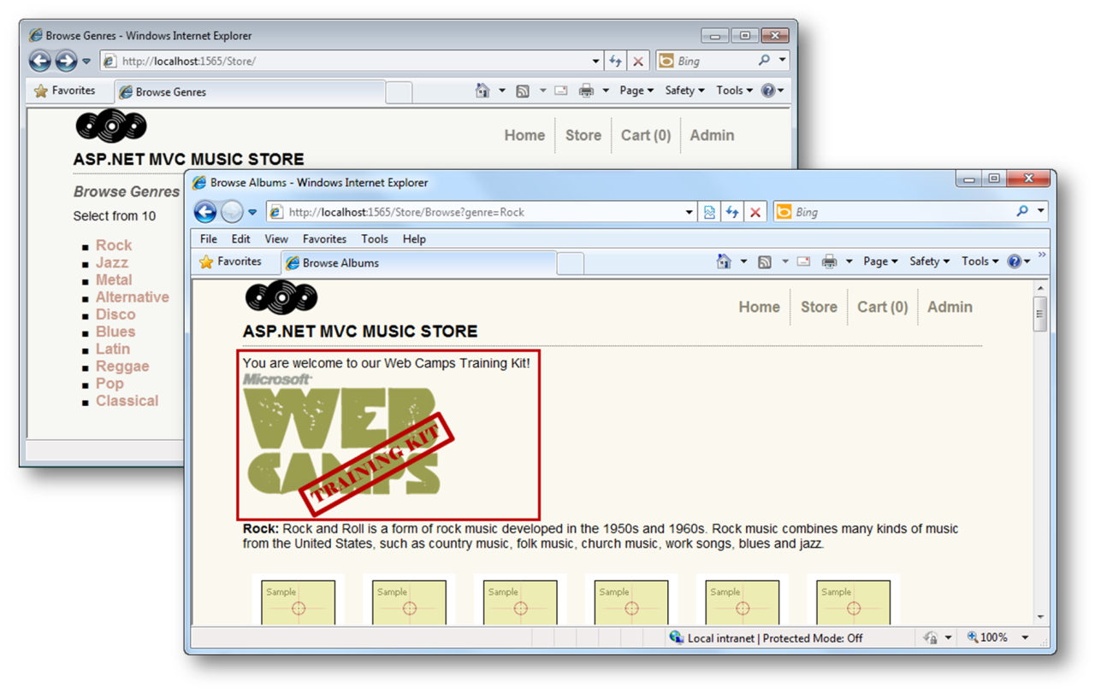
    - Figure 5
MVC Music Store - View Injection

  - Close the browser.

Next Step
Exercise 3: Injecting Action Filters

Exercise 3: Injecting Action Filters
In a previous Lab about Custom Action Filters you have been working with filters customization and injection. In this exercise,you will learn how to inject filters with Dependency Injection by using Unity Application Block containers. To do that, you will add to the Music Store Solution a custom action filter that will trace site activity.

Task 1 – Including the Tracking Filter in the Solution
In this task, you will include in the Music Store a custom action filter for event tracing. As filters were treated in a previous Lab “Custom Action Filters”, you will include the filter class from the Assets folder and then create a Filter Provider for Unity:
  - Open the begin solution at /Source/Ex03 – Injecting Filters/Begin/MvcMusicStore.sln.
  - Create the folder /Filters at project root.
  - Add the custom action filter TraceActionFilter.[cs|vb] to the project in the folder /Filters that you can find it at/Sources/Assets/TraceActionFilter.[cs|vb].
    - C# - TraceActionFilter.cs
    - using System;
    - using System.Collections.Generic;
    - using System.Linq;
    - using System.Web;
    - using System.Web.Mvc;

    - namespace MvcMusicStore.Filters
    - {
    - public class TraceActionFilter : IActionFilter
    - {
    - public void OnActionExecuted(ActionExecutedContext filterContext)
    - {
    - filterContext.HttpContext.Trace.Write("OnActionExecuted");
    - filterContext.HttpContext.Trace.Write("Action " + filterContext.ActionDescriptor.ActionName);
    - filterContext.HttpContext.Trace.Write("Controller " + filterContext.ActionDescriptor.ControllerDescriptor.ControllerName);
    - }

    - public void OnActionExecuting(ActionExecutingContext filterContext)
    - {
    - filterContext.HttpContext.Trace.Write("OnActionExecuting");
    - filterContext.HttpContext.Trace.Write("Action " + filterContext.ActionDescriptor.ActionName);
    - filterContext.HttpContext.Trace.Write("Controller " + filterContext.ActionDescriptor.ControllerDescriptor.ControllerName);
    - }
    - }
    - }

    - Visual Basic - TraceActionFilter.vb
    - Public Class TraceActionFilter
    - Implements IActionFilter

    - Public Sub OnActionExecuted(ByVal filterContext As ActionExecutedContext) Implements IActionFilter.OnActionExecuted
    - filterContext.HttpContext.Trace.Write("OnActionExecuted")
    - filterContext.HttpContext.Trace.Write("Action " & filterContext.ActionDescriptor.ActionName)
    - filterContext.HttpContext.Trace.Write("Controller " & filterContext.ActionDescriptor.ControllerDescriptor.ControllerName)
    - End Sub

    - Public Sub OnActionExecuting(ByVal filterContext As ActionExecutingContext) Implements IActionFilter.OnActionExecuting
    - filterContext.HttpContext.Trace.Write("OnActionExecuting")
    - filterContext.HttpContext.Trace.Write("Action " & filterContext.ActionDescriptor.ActionName)
    - filterContext.HttpContext.Trace.Write("Controller " & filterContext.ActionDescriptor.ControllerDescriptor.ControllerName)
    - End Sub

    - End Class

    - Note: This custom action filter performs ASP.NET tracing.
    - You can check “Global and Dynamic Action Filters” Lab for more reference.

  - Add the empty class FilterProvider.[cs|vb] to the project in the folder /Filters.
  - Include System.Web.Mvc and Microsoft.Practices.Unity namespaces in FilterProvider.[cs|vb].
    - (Code Snippet – ASP.NET MVC Dependency Injection – Ex03 Injecting Action Filters – FilterProvider namespace – Csharp)
    - C#
    - using System;
    - using System.Collections.Generic;
    - using System.Linq;
    - using System.Web;
    - using System.Web.Mvc;
    - using Microsoft.Practices.Unity;

    - namespace MvcMusicStore.Filters
    - {
    - public class FilterProvider
    - {
    - }
    - }

    - (Code Snippet – ASP.NET MVC Dependency Injection – Ex03 Injecting Action Filters – FilterProvider namespace – VB)
    - Visual Basic
    - Imports System.Web.Mvc
    - Imports Microsoft.Practices.Unity

    - Public Class FilterProvider

    - End Class

Make the class inherit from IFilterProvider Interface.
    - C#
    - using System;
    - using System.Collections.Generic;
    - using System.Linq;
    - using System.Web;
    - using System.Web.Mvc;
    - using Microsoft.Practices.Unity;

    - namespace MvcMusicStore.Filters
    - {
    - public class FilterProvider : IFilterProvider
    - {
    - }
    - }

    - Visual Basic
    - Imports System.Web.Mvc
    - Imports Microsoft.Practices.Unity

    - Public Class FilterProvider
    - Implements IFilterProvider

    - End Class

  - Add a IUnityContainer property in FilterProvider class, and then create a class constructor to set the container:
    - (Code Snippet – ASP.NET MVC Dependency Injection – Ex03 Injecting Action Filters – IUnityContainer – Csharp)
    - C#
    - using System;
    - using System.Collections.Generic;
    - using System.Linq;
    - using System.Web;
    - using System.Web.Mvc;
    - using Microsoft.Practices.Unity;

    - namespace MvcMusicStore.Filters
    - {
    - public class FilterProvider : IFilterProvider
    - {
    - IUnityContainer container;

    - public FilterProvider(IUnityContainer container)
    - {
    - this.container = container;
    - }

    - }
    - }

    - (Code Snippet – ASP.NET MVC Dependency Injection – Ex03 Injecting Action Filters – IUnityContainer – VB)
    - Visual Basic
    - Imports System.Web.Mvc
    - Imports Microsoft.Practices.Unity

    - Public Class FilterProvider
    - Implements IfilterProvider

    - Private container As IUnityContainer

    - Public Sub New(ByVal container As IUnityContainer)
    - Me.container = container
    - End Sub

    - End Class

    - Note: The filter provider class constructor is not creating a new object inside. The container is passed as a parameter, and the dependency is solved by Unity.

  - Implement in FilterProvider class the method GetFilters from IFilterProvider interface:
    - (Code Snippet – ASP.NET MVC Dependency Injection – Ex03 Injecting Action Filters – GetFilters – Csharp)
    - C#
    - using System;
    - using System.Collections.Generic;
    - using System.Linq;
    - using System.Web;
    - using System.Web.Mvc;
    - using Microsoft.Practices.Unity;

    - namespace MvcMusicStore.Filters
    - {
    - public class FilterProvider : IFilterProvider
    - {
    - IUnityContainer container;

    - public FilterProvider(IUnityContainer container)
    - {
    - this.container = container;
    - }

    - public IEnumerable<Filter> GetFilters(ControllerContext controllerContext, ActionDescriptor actionDescriptor)
    - {
    - foreach (IActionFilter actionFilter in container.ResolveAll<IActionFilter>())
    - yield return new Filter(actionFilter, FilterScope.First, null);
    - }
    - }
    - }

    - (Code Snippet – ASP.NET MVC Dependency Injection – Ex03 Injecting Action Filters – GetFilters – VB)
    - Visual Basic
    - Imports System.Web.Mvc
    - Imports Microsoft.Practices.Unity

    - Public Class FilterProvider
    - Implements IFilterProvider

    - Private container As IUnityContainer

    - Public Sub New(ByVal container As IUnityContainer)
    - Me.container = container
    - End Sub

    - Public Function GetFilters(ByVal controllerContext As ControllerContext,
    - ByVal actionDescriptor As ActionDescriptor
    - ) As IEnumerable(Of Filter) Implements System.Web.Mvc.IFilterProvider.GetFilters

    - Dim result = New List(Of Filter)()
    - For Each actionFilter As IActionFilter In container.ResolveAll(Of IActionFilter)()
    - result.Add(New Filter(actionFilter, FilterScope.First, Nothing))
    - Next actionFilter

    - Return result
    - End Function

    - End Class

    - Note: This implementation of GetFilters method is shorter than the one you have learned in “Global and Dynamic Action Filters” lab, where you ask if each controller or action was inside a list of accepted items.

Task 2 – Registering and Enabling the Filter
In this task, you will enable site tracking and then you will register the filter in Global.asax.[cs|vb] Application_Start method to start tracing:
  - Open Web.config at project root and enable trace tracking at System.Web group:
    - XML
    - <system.web>
    - <trace enabled="true"/>
    - <compilation debug="true" targetFramework="4.0">

  - Open Global.asax.[cs|vb] at project root.
  - If you are using C#, add a reference to the Filters namespace:
    - C#
    - using System;
    - using System.Collections.Generic;
    - using System.Linq;
    - using System.Web;
    - using System.Web.Mvc;
    - using System.Web.Routing;
    - using Microsoft.Practices.Unity;
    - using MvcMusicStore.Services;
    - using MvcMusicStore.Factories;
    - using MvcMusicStore.Controllers;
    - using MvcMusicStore.Filters;

    - namespace MvcMusicStore

  - Select Application_Start method and register the filter in the Unity Container. You will have to register the filter provider and the action filter as well:
    - (Code Snippet – ASP.NET MVC Dependency Injection – Ex03 Injecting Action Filters – Global asax unity registration - CSharp)
    - C#
    - protected void Application_Start()
    - {
    - AreaRegistration.RegisterAllAreas();

    - RegisterGlobalFilters(GlobalFilters.Filters);
    - RegisterRoutes(RouteTable.Routes);

    - var container = new UnityContainer();
    - container.RegisterType<IStoreService, StoreService>();
    - container.RegisterType<IController, StoreController>("Store");

    - var factory = new UnityControllerFactory(container);
    - ControllerBuilder.Current.SetControllerFactory(factory);

    - IDependencyResolver resolver = DependencyResolver.Current;

    - container.RegisterInstance<IMessageService>(new MessageService {
    - Message = "You are welcome to our Web Camps Training Kit!",
    - ImageUrl = "/Content/Images/logo-webcamps.png"
    - });
    - container.RegisterType<IViewPageActivator, CustomViewPageActivator>(new InjectionConstructor(container));

    - container.RegisterInstance<IFilterProvider>("FilterProvider", new FilterProvider(container));
    - container.RegisterInstance<IActionFilter>("LogActionFilter", new TraceActionFilter());

    - IDependencyResolver newResolver = new UnityDependencyResolver(container, resolver);

    - DependencyResolver.SetResolver(newResolver);
    - }

    - (Code Snippet – ASP.NET MVC Dependency Injection – Ex03 Injecting Action Filters – Global asax unity registration - VB)
    - Visual Basic
    - Protected Sub Application_Start()

    - AreaRegistration.RegisterAllAreas()

    - RegisterGlobalFilters(GlobalFilters.Filters)
    - RegisterRoutes(RouteTable.Routes)

    - Dim container = New UnityContainer
    - container.RegisterType(Of IStoreService, StoreService)()
    - container.RegisterType(Of IController, StoreController)("Store")

    - Dim factory = New UnityControllerFactory(container)
    - ControllerBuilder.Current.SetControllerFactory(factory)

    - Dim resolver As IDependencyResolver = DependencyResolver.Current

    - container.RegisterInstance(Of IMessageService)(New MessageService With {
    - .Message = "You are welcome to our Web Camps Training Kit!",
    - .ImageUrl = "/Content/Images/logo-webcamps.png"})

    - container.RegisterType(Of IViewPageActivator,
    - CustomViewPageActivator)(New InjectionConstructor(container))

    - container.RegisterInstance(Of IFilterProvider)("FilterProvider", New FilterProvider(container))
    - container.RegisterInstance(Of IActionFilter)("LogActionFilter", New TraceActionFilter)

    - Dim newResolver As IDependencyResolver = New UnityDependencyResolver(container, resolver)

    - DependencyResolver.SetResolver(newResolver)

    - End Sub

Task 3 – Running the Application
In this task, you will run the application and test that the custom action filter is tracing the activity:
  - Press F5 to run the application.
  - Browse to /Store and choose ‘Rock’ genre. You can browse to more genres if you want to.
    - 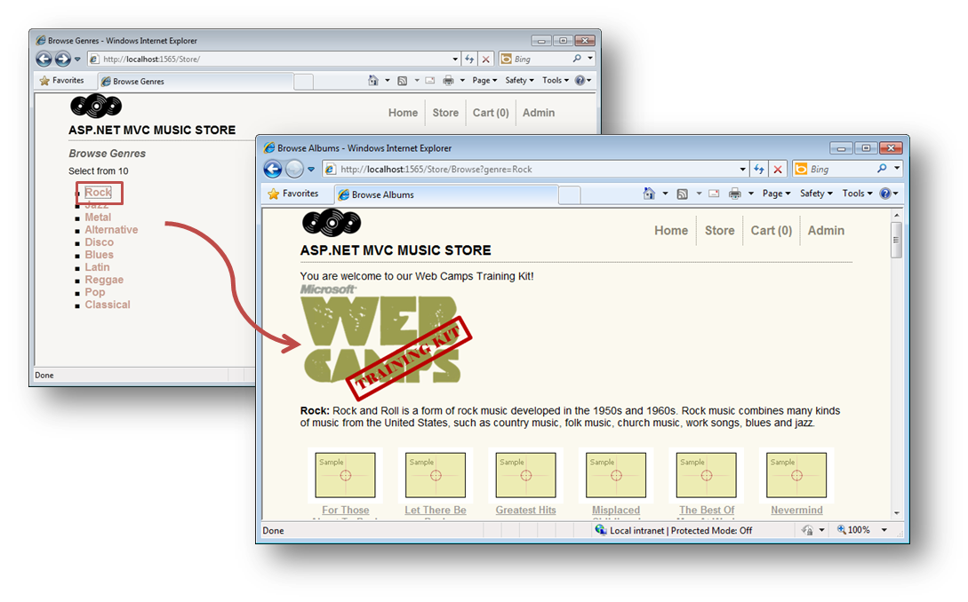
    - Figure 6
    - Music Store

  - Browse to /Trace.axd to see the Application Trace page, and then click the ‘View Details’ link at the right column for Store/:
    - 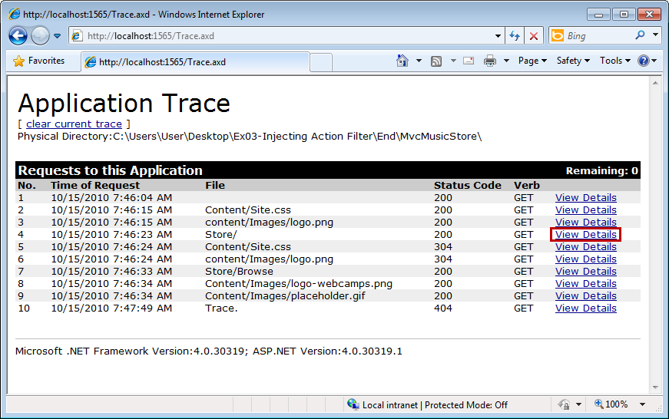
    - Figure 7
    - Application Trace Log

    - 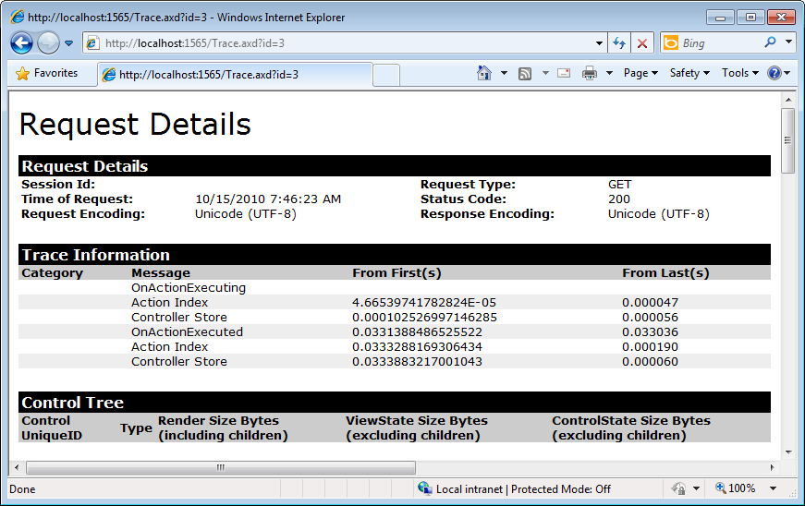
    - Figure 8
    - Application Trace – Request Details

  - Close the browser.

Next Step
Summary

Summary
By completing this Hands-On Lab you have learned how to use Dependency Injection in MVC 3 by integrating Unity Application Block. To achieve that purpose you have used Dependency Injection inside controllers, views and action filters.
The following concepts were used:
MVC 3 Dependency Injection new features
Unity Application Block integration
Dependency Injection in Controllers
Dependency Injection in Views
Dependency injection of Action Filters

